HP-UX 10.20 Security for DSS requirements.
Originally written by: Darren Bennett 11/05/03
Updated/Edited: Darren Bennett 11/14/03
Updated/Edited: Darren Bennett 08/13/04

I. Configure Login Banners:

There are two scenarios regarding Login Banners, the first assumes that you previously edited and saved the files to a DOS formatted floppy. The second scenario explains how to modify/create the files yourself.

A. If you have pre-saved the Banner files on a floppy:
** Be sure it is write protected and virus free**

Perform the following as root to mount the floppy and then copy the files to the locations specified in step 2:

1. To transfer a file from a PC floppy to the UNIX system:
doscp /dev/rfloppy/c0t1d0:<DOS-Filename> <UNIX- Filename and Path>
2. Copy Xresources to /etc/dt/config/C/Xresources and copy
issue to /etc/issue
3. Skip ahead to part II.

Additional transfer notes:
To view the contents of a DOS floppy: type “dosls -a /dev/rfloppy/c0t1d0:”
To view the contents of a UNIX directory type “ls –al </path/to/the/directory>”
To view the contents of a UNIX file type “more </path/to/filename>”

B. If you do not have pre-saved copies of the Xresources and issue files:

Step 1:

Copy the example Xresources file from /usr/dt/config/C/Xresources to /etc/dt/config/C/Xresources and edit it to match the following (Changes made to the default file have been highlighted), or create a new file containing the following and save it to /etc/dt/config/C/Xresources:

**-- Begin Copying for Xresources file Below This Line --**

!!######################################################################
!!
!! Xresources
!!
!! Common Desktop Environment
!!
!! Configuration file for the Login Manager
!!
!! (c) Copyright 1993, 1994 Hewlett-Packard Company
!! (c) Copyright 1993, 1994 International Business Machines Corp.
!! (c) Copyright 1993, 1994 Sun Microsystems, Inc.
!! (c) Copyright 1993, 1994 Novell, Inc.
!!
!! ************** DO NOT EDIT THIS FILE **************
!!
!! /usr/dt/config/Xresources is a factory-default file and will
!! be unconditionally overwritten upon subsequent installation.
!! Before making changes to the file, copy it to the configuration
!! directory, /etc/dt/config. You must also update the resources
!! resource in /etc/dt/config/Xconfig.
!!
!! $Revision: 1.1 $
!!
!!######################################################################
!!
!!
!! This file contains appearance and behaviour resources for the Dtlogin
!! login screen. These are designed to be read into the root window
!! property via the 'xrdb' program. Dtlogin will do this automatically
!! after the server is reset and will remove them before the session
!! starts.
!!
!! Dtlogin contains internal default values for all resources. To
!! override a default value, uncomment the appropriate line below and
!! supply the desired value.
!!
!! Customization hints are included at the end of this file.
!!
!!

!!######################################################################
!!
!! Motif visuals
!!

*XmCascadeButton*shadowThickness: 1
*XmDrawnButton*shadowThickness: 1
*XmPushButton*shadowThickness: 1
*XmPushButtonGadget*shadowThickness: 1
*XmText*shadowThickness: 1
*XmTextField*shadowThickness: 1
*enableButtonTab: True
*enableDefaultButton: True
*enableEtchedInMenu: True
*enableMenuInCascade: True
*enableMultiKeyBindings: True
*enableToggleColor: True
*enableToggleVisual: True
*highlightThickness: 1

!!######################################################################
!!
!! COLORS
!!
!! #a8a8a8 = lightgray
!! #7e7e7e = gray (darker shade)
!! #ef506f = burgundy
!!

!! Dtlogin*foreground: black

#ifdef COLOR
!! Dtlogin*background: #a8a8a8
!! Dtlogin*highlightColor: #ef506f
!! Dtlogin*logo*Background: #ef506f
#else
!! Dtlogin*background: white
#endif

!!######################################################################
!!
!! FONTS
!!
!! labelFont button and label text
!! textFont help and error dialog text
!!

#if WIDTH < 1024
Dtlogin*labelFont: -dt-interface system-medium-r-normal-l*-*-*-*-*-*-*-*-*:
Dtlogin*textFont: -dt-interface user-medium-r-normal-l*-*-*-*-*-*-*-*-*:
Dtlogin*greeting.fontList: -dt-interface system-medium-r-normal-l*-*-*-*-*-*-*-*-*:
#else
Dtlogin*labelFont: -dt-interface system-medium-r-normal-l*-*-*-*-*-*-*-*-*:
Dtlogin*textFont: -dt-interface user-medium-r-normal-l*-*-*-*-*-*-*-*-*:
Dtlogin*greeting.fontList: -dt-interface system-medium-r-normal-l*-*-*-*-*-*-*-*-*:
#endif

!!######################################################################
!!
!! CURSOR
!!
!! False = The MIT "X" cursor (default)
!! True = The left pointer cursor

Dtlogin*workspaceCursor: True

!!######################################################################
!!
!! GREETING
!!

!! Dtlogin*greeting.foreground: black
!! Dtlogin*greeting.background: #a8a8a8
Dtlogin*greeting.labelString: **DoD Warning Banner** \
\n Use of this or any other DoD interest computer system constitutes a consent \
\n to monitoring at all times. This is a DoD interest computer system. All DoD \
\n interest computer systems and related equipment are intended for the \
\n communication, transmission, processing, and storage of official U.S. \
\n Government or other authorized information only. All DoD interest computer \
\n systems are subject to monitoring at all times to ensure proper functioning \
\n of equipment and systems including security devices and systems, to prevent \
\n unauthorized use and violations of statutes and security regulations, to \
\n deter criminal activity, and for other similar purposes. Any user of a DoD \
\n interest computer system should be aware that any information placed in the \
\n system is subject to monitoring and is not subject to any expectation of \
\n privacy. If monitoring of this or any other DoD interest computer system \
\n reveals possible evidence of violation of criminal statutes, this evidence \
\n and any other related information, including identification information \
\n about the user, may be provided to law enforcement officials. If monitoring \
\n of this or any other DoD interest computer systems reveals violations of \
\n security regulations or unauthorized use, employees who violate security \
\n regulations or make unauthorized use of DoD interest computer systems are \
\n subject to appropriate disciplinary action. Use of this or any other DoD \
\n interest computer system constitutes a consent to monitoring at all times.

Dtlogin*greeting.persLabelString: Hello %s
!! Dtlogin*greeting.alignment: ALIGNMENT_CENTER

!!######################################################################
!!
!! Size of Text Input Area
!!

Dtlogin*login_text.columns: 20
Dtlogin*passwd_text.columns: 20

!!######################################################################
!!
!! MISC
!!

Dtlogin*logo*bitmapFile: /etc/dt/config/C/logo.xpm

Dtlogin*preeditType:

!!######################################################################
!!
!! LANGUAGE MENU NAME MAPPINGS

#undef C
Dtlogin*C.languageName: C
Dtlogin*C.iso88591.languageName: C.ISO8859-1
Dtlogin*POSIX.languageName: POSIX
Dtlogin*arabic-w.languageName: Algerian.Arabic8
Dtlogin*arabic.languageName: Arabic.Arabic8
Dtlogin*arabic.iso88596.languageName: Arabic.ISO8859-6
Dtlogin*bulgarian.languageName: Bulgarian.ISO8859-5
Dtlogin*czech.languageName: Czech.ISO8859-2
Dtlogin*danish.iso88591.languageName: Danish.ISO8859-1
Dtlogin*danish.languageName: Danish.Roman8
Dtlogin*german.iso88591.languageName: German.ISO8859-1
Dtlogin*german.languageName: German.Roman8
Dtlogin*greek.languageName: Greek.Greek8
Dtlogin*greek.iso88597.languageName: Greek.ISO8859-7
Dtlogin*english.iso88591.languageName: English-UK.ISO8859-1
Dtlogin*english.languageName: English-UK.Roman8
Dtlogin*american.iso88591.languageName: English-US.ISO8859-1
Dtlogin*american.languageName: English-US.Roman8
Dtlogin*spanish.iso88591.languageName: Spanish.ISO8859-1
Dtlogin*spanish.languageName: Spanish.Roman8
Dtlogin*finnish.iso88591.languageName: Finnish.ISO8859-1
Dtlogin*finnish.languageName: Finnish.Roman8
Dtlogin*c-french.iso88591.languageName: French-Canadian.ISO8859-1
Dtlogin*c-french.languageName: French-Canadian.Roman8
Dtlogin*french.iso88591.languageName: French.ISO8859-1
Dtlogin*french.languageName: French.Roman8
Dtlogin*serbocroatian.languageName: Croatian.ISO8859-2
Dtlogin*hungarian.languageName: Hungarian.ISO8859-2
Dtlogin*icelandic.iso88591.languageName: Icelandic.ISO8859-1
Dtlogin*icelandic.languageName: Icelandic.Roman8
Dtlogin*italian.iso88591.languageName: Italian.ISO8859-1
Dtlogin*italian.languageName: Italian.Roman8
Dtlogin*hebrew.languageName: Hebrew.Hebrew8
Dtlogin*hebrew.iso88598.languageName: Hebrew.ISO8859-8
Dtlogin*japanese.languageName: Japanese.SJIS
Dtlogin*japanese.euc.languageName: Japanese.EUC
Dtlogin*katakana.languageName: Japanese.KANA8
Dtlogin*korean.languageName: Korean.EUC
Dtlogin*dutch.iso88591.languageName: Dutch.ISO8859-1
Dtlogin*dutch.languageName: Dutch.Roman8
Dtlogin*norwegian.iso88591.languageName: Norwegian.ISO8859-1
Dtlogin*norwegian.languageName: Norwegian.Roman8
Dtlogin*polish.languageName: Polish.ISO8859-2
Dtlogin*portuguese.iso88591.languageName: Portuguese.ISO8859-1
Dtlogin*portuguese.languageName: Portuguese.Roman8
Dtlogin*rumanian.languageName: Rumanian.ISO8859-2
Dtlogin*russian.languageName: Russian.ISO8859-5
Dtlogin*slovak.languageName: Slovak.ISO8859-2
Dtlogin*slovene.languageName: Slovene.ISO8859-2
Dtlogin*swedish.iso88591.languageName: Swedish.ISO8859-1
Dtlogin*swedish.languageName: Swedish.Roman8
Dtlogin*thai.languageName: Thai.TIS620
Dtlogin*turkish.iso88599.languageName: Turkish.ISO8859-9
Dtlogin*turkish.languageName: Turkish.Turkish8
Dtlogin*chinese-s.languageName: Chinese-s.HP15
Dtlogin*chinese-t.big5.languageName: Chinese-t.BIG5
Dtlogin*chinese-t.languageName: Chinese-t.CCDC

!!######################################################################
!!
!! CHOOSER
!!
dtchooser*chlistFont: -dt-interface user-medium-r-normal-s*-*-*-*-*-*-*-*-*:
dtchooser*visibleItemCount: 10

!!****************************************************************************
!!
!! CUSTOMIZATION HINTS
!!
!!
!! The login screen was designed to be easy to customize for a variety of
!! attributes. These include...
!!
!! 1. custom logo bitmap
!! 2. custom greeting message
!! 3. colors
!! 4. fonts
!!
!! Users may replace the default logo with a custom one of their choice.
!!
!! Colors and fonts can be changed using the standard Motif resources for
!! the appropriate widget and/or class.

**-- End Copying for Xresources File Above This Line --**

Step 2:

Create a file /etc/issue and place the following in it:

**-- Begin Copying for issue File Below This Line --**

**DoD Warning Banner**
Use of this or any other DoD interest computer system constitutes consent to monitoring at all times. This is a DoD interest computer system. All DoD interest computer systems and related equipment are intended for the communication, transmission, processing, and storage of official U.S. Government or other authorized information only. All DoD interest computer systems are subject to monitoring at all times to ensure proper functioning of equipment and systems including security devices and systems, to prevent unauthorized use and violations of statutes and security regulations, to deter criminal activity, and for other similar purposes. Any user of a DoD interest computer system should be aware that any information placed in the system is subject to monitoring and is not subject to any expectation of privacy. If monitoring of this or any other DoD interest computer system reveals possible evidence of violation of criminal statutes, this evidence and any other related information, including identification information about the user, may be provided to law enforcement officials. If monitoring of this or any other DoD interest computer systems reveals violations of security regulations or unauthorized use, employees who violate security regulations or make unauthorized use of DoD interest computer systems are subject to appropriate disciplinary action. Use of this or any other DoD interest computer system constitutes a consent to monitoring at all times.

**-- End Copying for issue File Above This Line --**

Step 3:

Enable banners for telnet access to the system:

a. Edit /etc/inetd.conf
b. Append "-b /etc/issue" to the "telnet" entry.
(the line should end with "telnetd -b /etc/issue")

c. From the command line, determine the Process ID (PID) for inetd:

Type "ps -ef |grep inetd”. (The PID is the first number from the right. In the example below, it is 449)
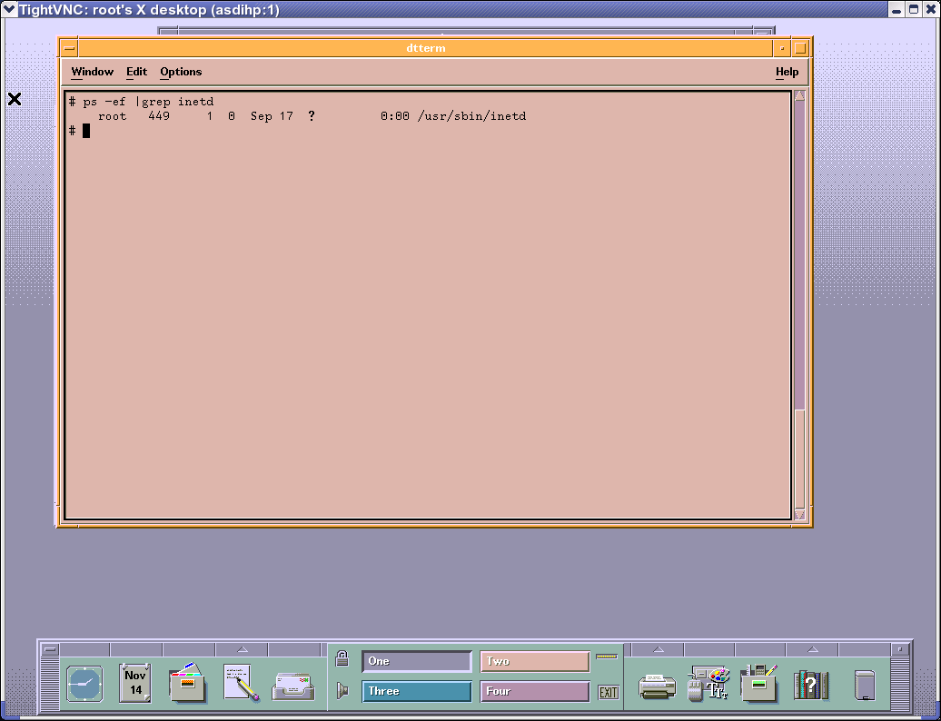

d. Restart inetd to load your changes:

Type “kill -HUP <PID of inetd>"

II. Disable access to the system PROM

a. Reboot the system via the "reboot" command (you must be root to do this)
b. During the boot process, you will be prompted with "to discontinue, press any key within 10 seconds" (press a key)
c. Type "CO" (for the Configuration Menu)
d. Type "SEC ON" (to enable secure boot mode)
e. Type "BIN"
- Verify that both Primary and Secondary boot devices have the same SCSI ID.
- Check that the Secure flag is set to ON and auto search is OFF
f. Type “RESET” to reboot the system with your changes enabled.

**To re-enable PROM access at a later time, shutdown the system and remove the hard disks. Re-boot the system and disable the “SEC OFF” command using the same steps as above, shut down the system again, replace the drives and restart the system**

III. Configure Auditing

a. Login as root
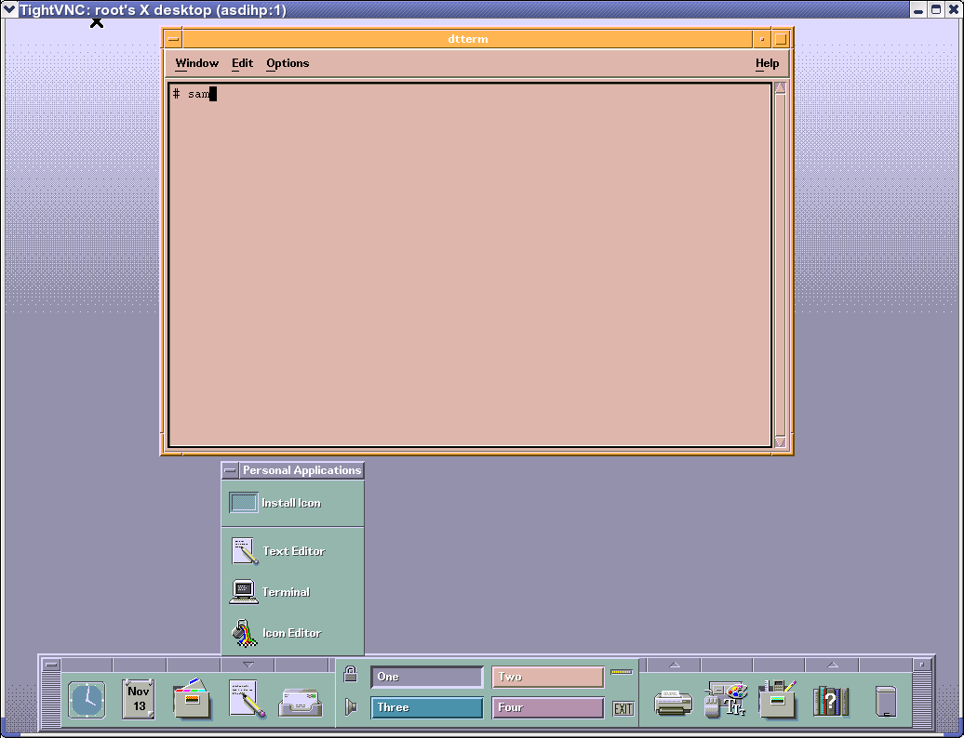
b. Open a terminal and type "sam" from within the terminal

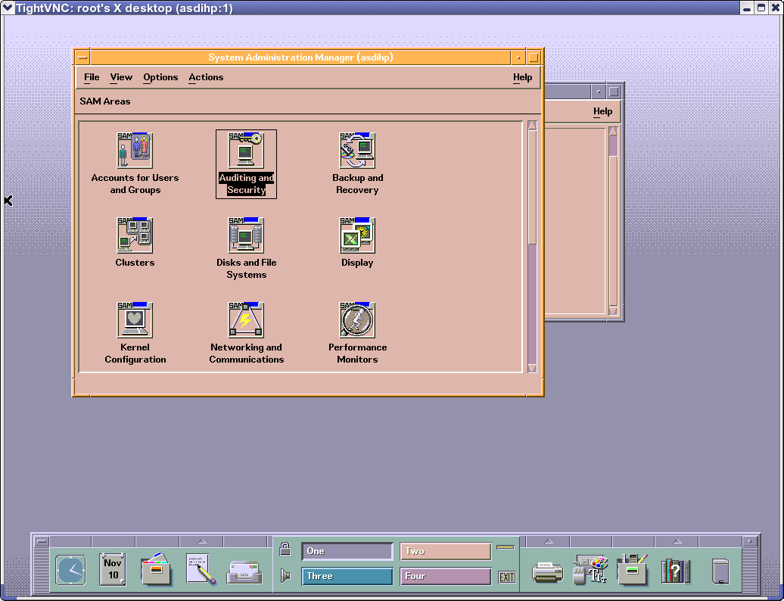
c. Select "Auditing and Security"

d. Select "Audited Events"

**If this is the first time you have done this or the “audnames” file does not exist, you will first be prompted if one should be created (select yes)**

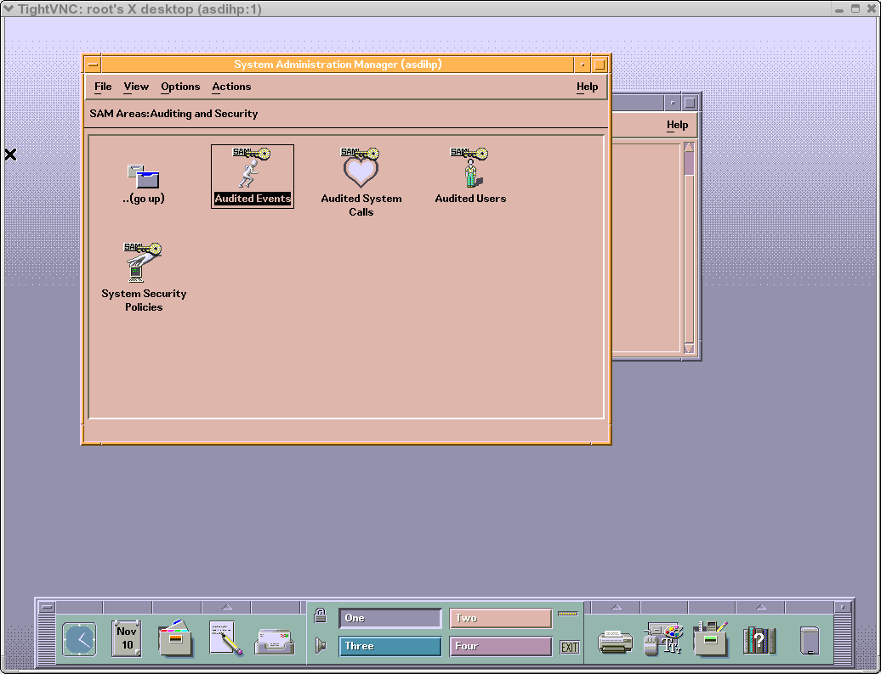

e. Make sure the following items are selected for auditing:
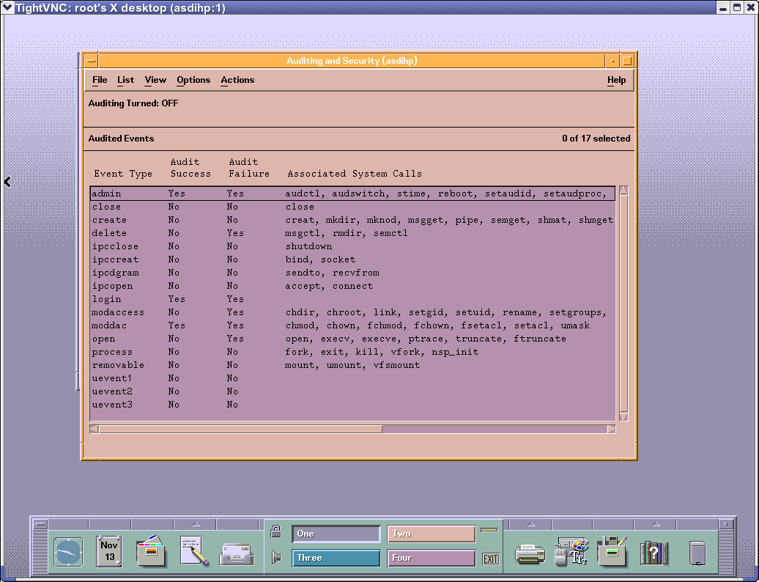
(“Right Click” on the item to change its status)

f. Select “System Security Policies” (Double Click)
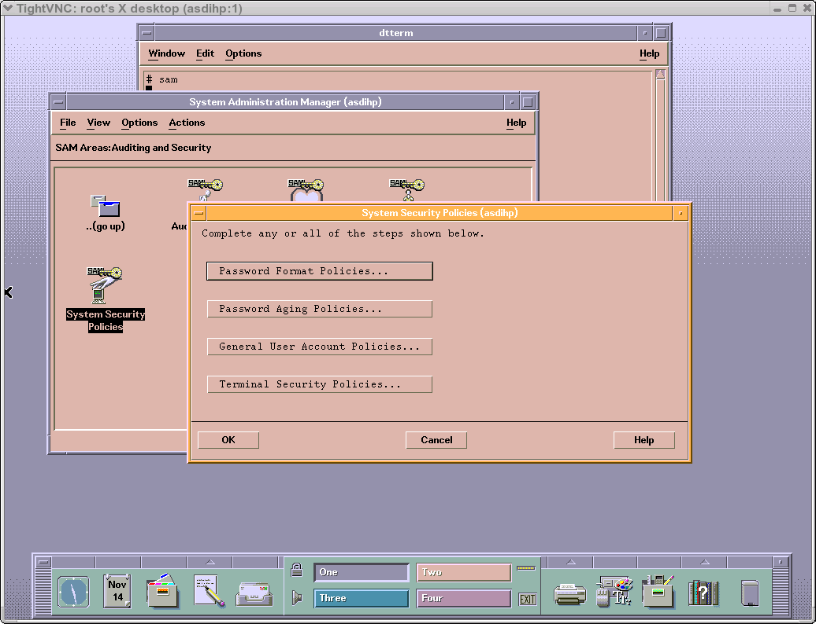
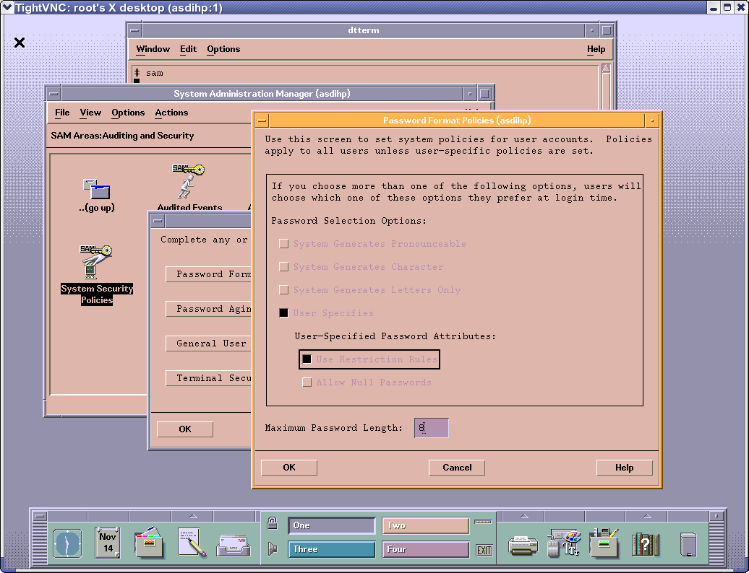
g. Select “Password Format Policies”, “Password Aging Policies”, “General User Account Policies”, and “Terminal Security Policies” and be sure they match the settings in the four images below:

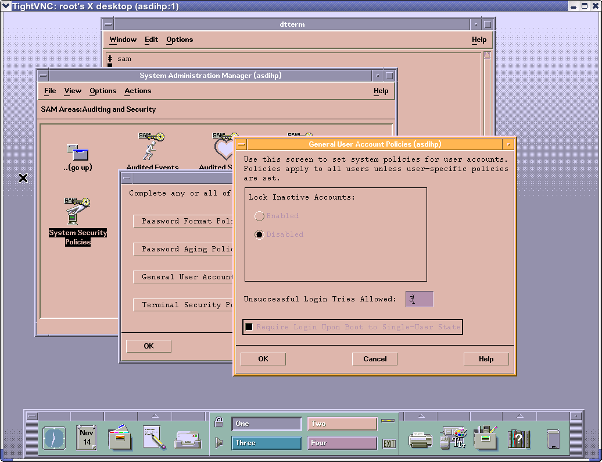
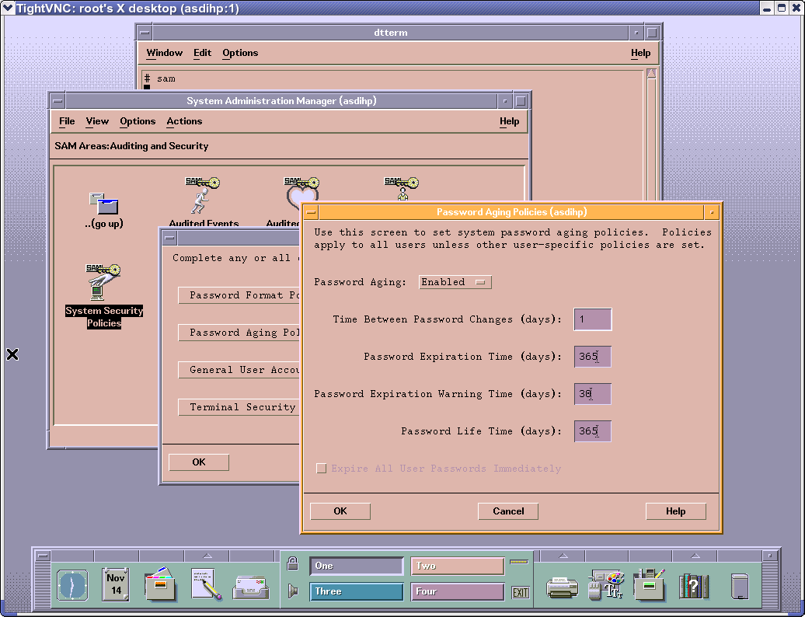

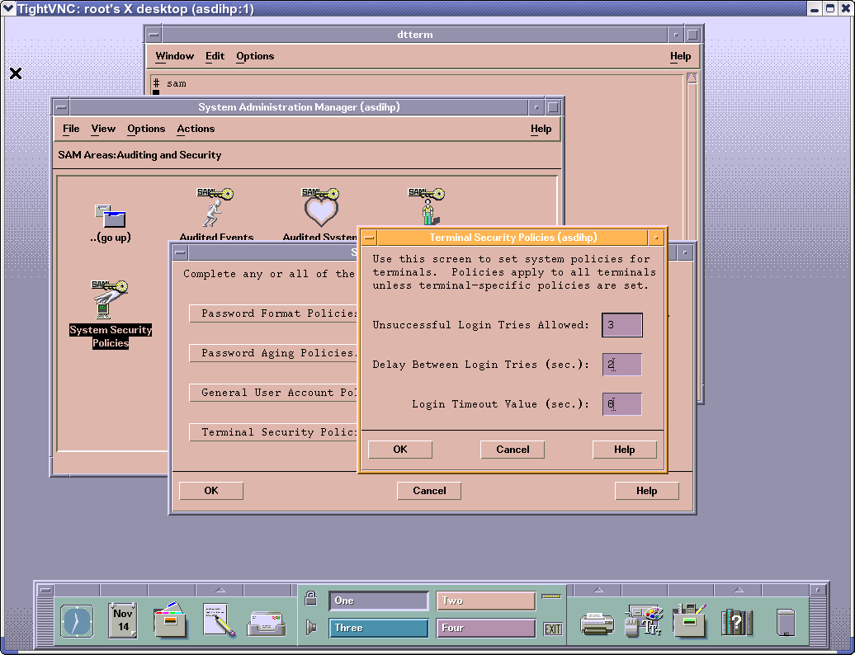

h. Select “Audited Events” Again

i. "Actions, Turn Auditing ON"

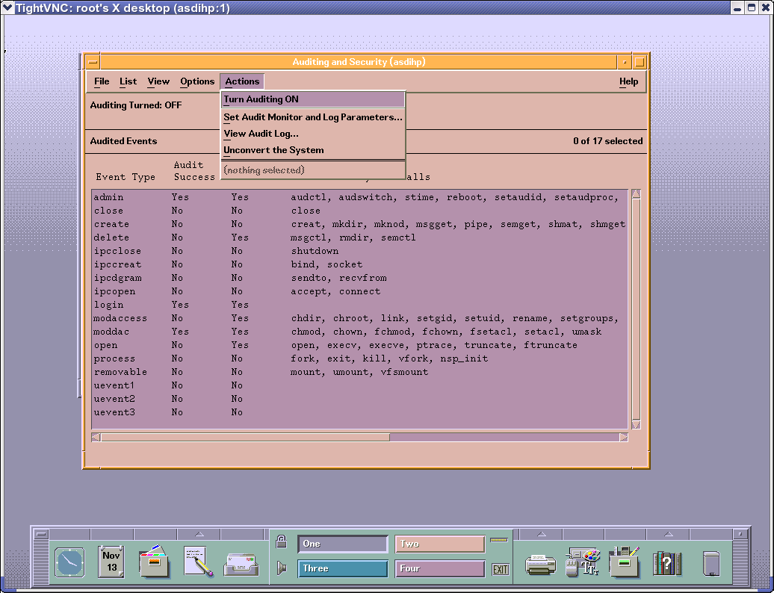

IV. Congratulations! You have finished.

